CS147 Winter 2022
Thomas E., Frieda G., Rickenson R., Kelsey Z.
amble
Introduction
Value Proposition
Feed your curiosities
Mission Statement
Explore your curiosities and unearth your creativity at your own pace.
Problem/Solution Overview
People have a difficult time starting new hobbies and exploring their own creativity. It’s hard to get motivated in a world bombarding you with information and distractions, telling you creativity is something you’re “born with,” and social media constantly comparing you to professionals.
amble gives users a way to explore a variety of hobbies, individually or with others, in an engaging and motivating pace that is focused on having fun and exploration. The more users explore hobbies and interact with amble, the better they can gauge what kind of interests they enjoy, and they can meet others throughout the process!

Needfinding: Interviews
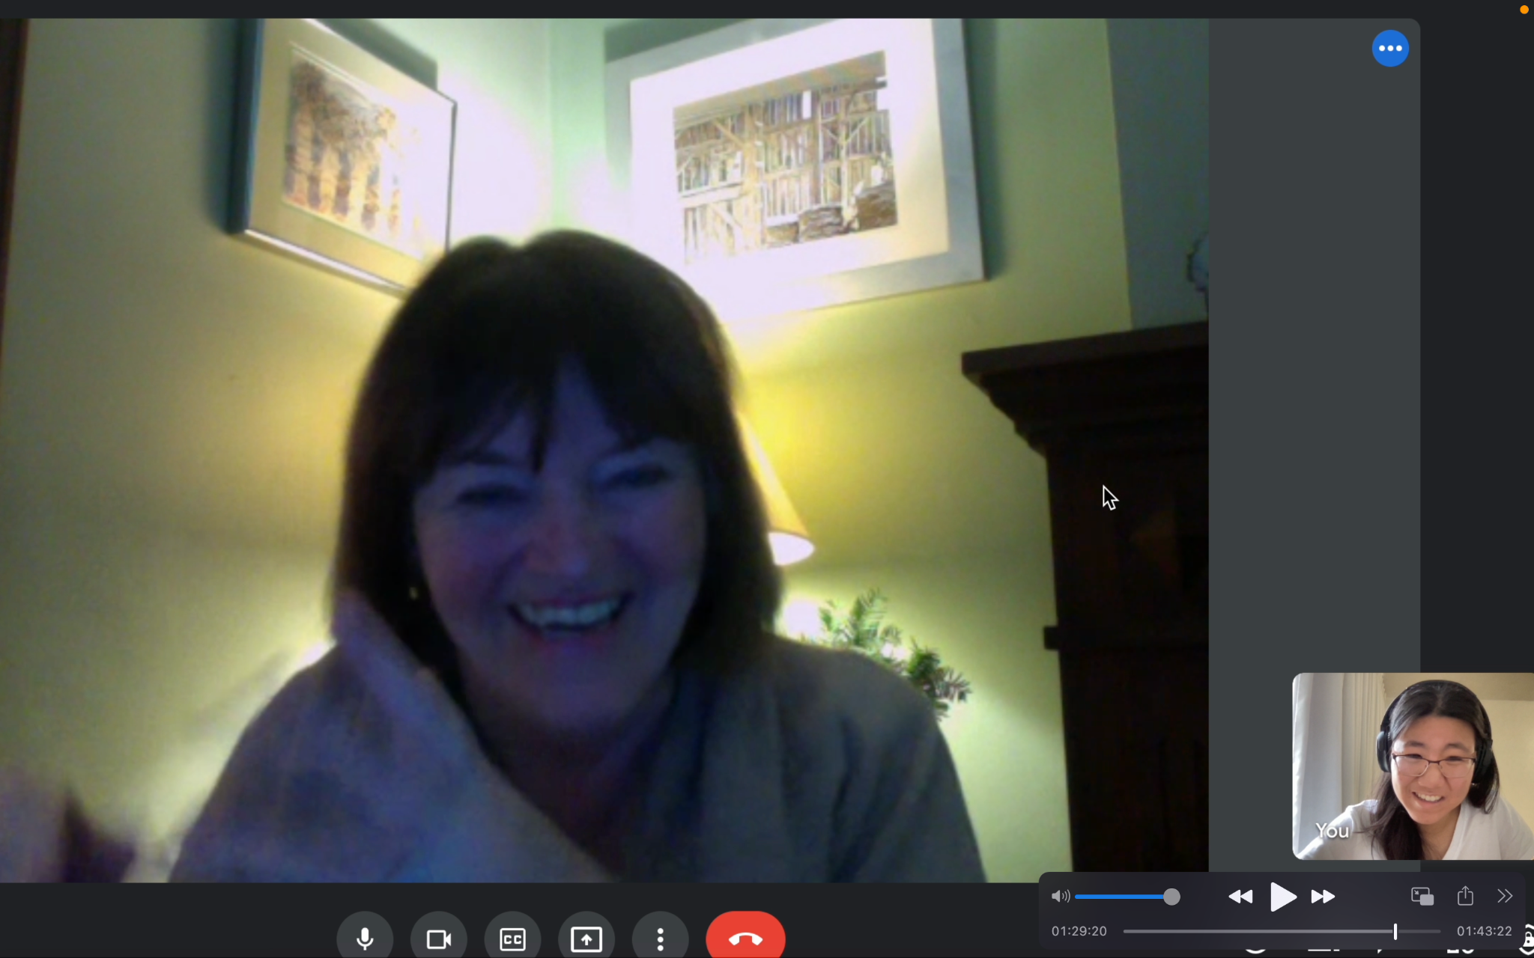
Team member (Frieda; to the right) conducting a digital interview.

We conducted interviews in-person and through Zoom. Interviewees consisted of participants with different professional backgrounds, ages, and sensical abilities. We interviewed graphic designers, playwrights, college students, engineers, moms, teachers. Participants were young adults, up to participants that were 75 years of age. Through our interviews, we wanted to gauge what senses do these participants use the most on a day-to-day basis? Thus, we also interviewed extreme users, such as users with ‘heightened’ senses, due to their professions, hobbies, etc, and users with inherently less sense capabilities.

Through the interviews, we obtained insights on behaviors, motivations, and inspirations as it applies to interviewees’ control and use of their senses. We found that distractions & lack of discipline are primary setbacks to learning & hobby-making, and about the memory gained through sensing (kinesthesia). Users also expressed self-awareness of improvement and access to resources. Overall, there was a strong correlation in creativity with elevating the human experience.

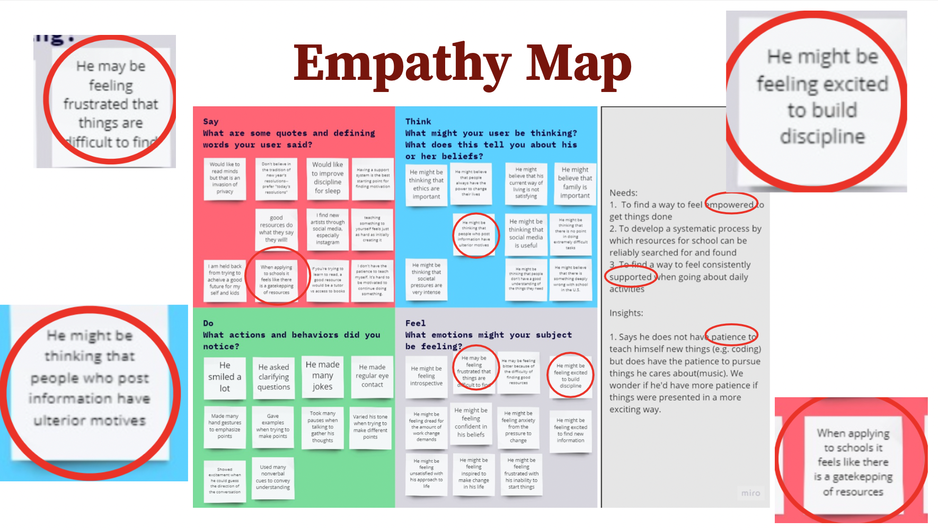
Empathy map for a graphic designer interviewee.

POVs & Experience Prototypes
Final POV’s
POV 1: We met Edgar, a recently graduated graphic designer who is about to begin his graphic design career. We were surprised to notice the short length of his responses. We wonder if this means he feels intimidated and unsure about his voice as a designer entering the design world. It would be game-changing to provide some sort of security blanket and confidence in his design.
POV 2: We met Alison, a sophomore who just started a new quarter at Stanford and wants to get better at playing drums. We were surprised to notice her low levels of self-efficacy regarding her ability to be motivated, despite the fact that she has so many hobbies and skills. We wonder if this means she feels pressured to be perfect at what she tries and if this in itself is demotivating towards starting something new. It would be game-changing to give her the confidence and belief that she can succeed at new things, and redefine what that ‘success’ looks like.

POV 3: We met Destine, a college sophomore in the process of transferring from his community college to a four year university. We were surprised when he said that many online resources that he has found do not do what they say they will. We wonder if this means he is unsure of how to separate good material from bad. It would be game-changing to provide him with some way of verifying the legitimacy of online material before putting energy into exploring them.
Sample How Might We’s
> How might we help him embrace the idea of failure in a healthy way?...From POV 1
> How might we make picking up a new hobby less focused on the end result and more on the journey?...From POV 2
> How might we help people find the information they want?...From POV 3

Top 3 Solutions

- solution: provide a visual that shows when the user is stepping outside of their comfort zone and give them a starting point/roadmap of useful resources that they don’t have to find themselves.

- solution: turn it into a social experience with other journey-goers!

- solution: make daily life a source of helpful information by aggregating and compiling info for future use.

Experience Prototypes

Prototype 1:
We asked the participant to rank grammar topics on a scale of least to most comfortable. Then we asked them to take 2 tests; on the first one they did not receive any help, on the second one they got notified before they answered a question that falls into one of their uncomfortable categories. They were provided a link and a minute to read important information. At the end we asked them to compare the two experiences and describe their overall level of confidence and direction.

Assumption tested:
When people are given support when doing things they are uncomfortable with, they feel like they have a stronger sense of confidence.

What worked:
- Straightforward, easy-to-understand concept
- Participant was willing to be vulnerable

What didn’t work:
- Couldn’t find a way to seamlessly interject without disrupting concentration
- Not enough time for the user to absorb much information

Prototype 2:
This prototype involved making origami by collaborating with another person. Two participants were given a single set of instructions and materials to make different kinds of origami. They had to make 3 different origami pieces each - of easy, medium, and hard difficulty levels - and were questioned before and after the experience, regarding their enjoyment towards the hobby (origami-making) and their experience level in the hobby.

Assumptions tested:
Socializing with others makes you more focused on the present moment, and doing hobbies with others can be more fun and motivating
What worked:
- social → fun! → more interested in the hobby itself
- single, shared instruction set → more interaction
- multiple experience levels → better-matching engagement

What didn’t work:
- social aspect took some of the focus away
- some comparison of end results with one another

Prototype 3:
Participants recorded tidbits of information throughout the day that they felt could be useful to remember in the future. They were asked to jot down what the information was (a quote, a fact, a feeling, a recommendation, a realization, etc.) and the source, time, place, and purpose (if they felt were necessary to include) onto a pad of sticky notes with a pen and later to reflect on the experience of recording in the moment as well as revisiting the information at the end of the day.

Assumption tested:
People will want to store and look back at the events and experiences of their day for learning and recall purposes.

What worked:
- loved how record was: concrete, permanent, detailed
- → helped resurface & recall thoughts
- felt most inclined to capture really happy joyful experiences
What didn’t work:
- the process could be: awkward, inconvenient, impractical
  - manually transcribing is slower than thinking!
- space-constrained
- afraid to lose the sticky pad
- might need a prompt/reminder to return to these records

Prototyping: Design Evolution
Initial Sketches
gan the prototyping process with different kinds of sketches that focused on different design directions, and had two main models - a mobile application and an AR approach. After evaluating these sketch models on technological accessibility, sensory input, and functionality, , we chose to stick with the mobile application and develop our tasks from this model.
Concept Sketch - Mobile Application
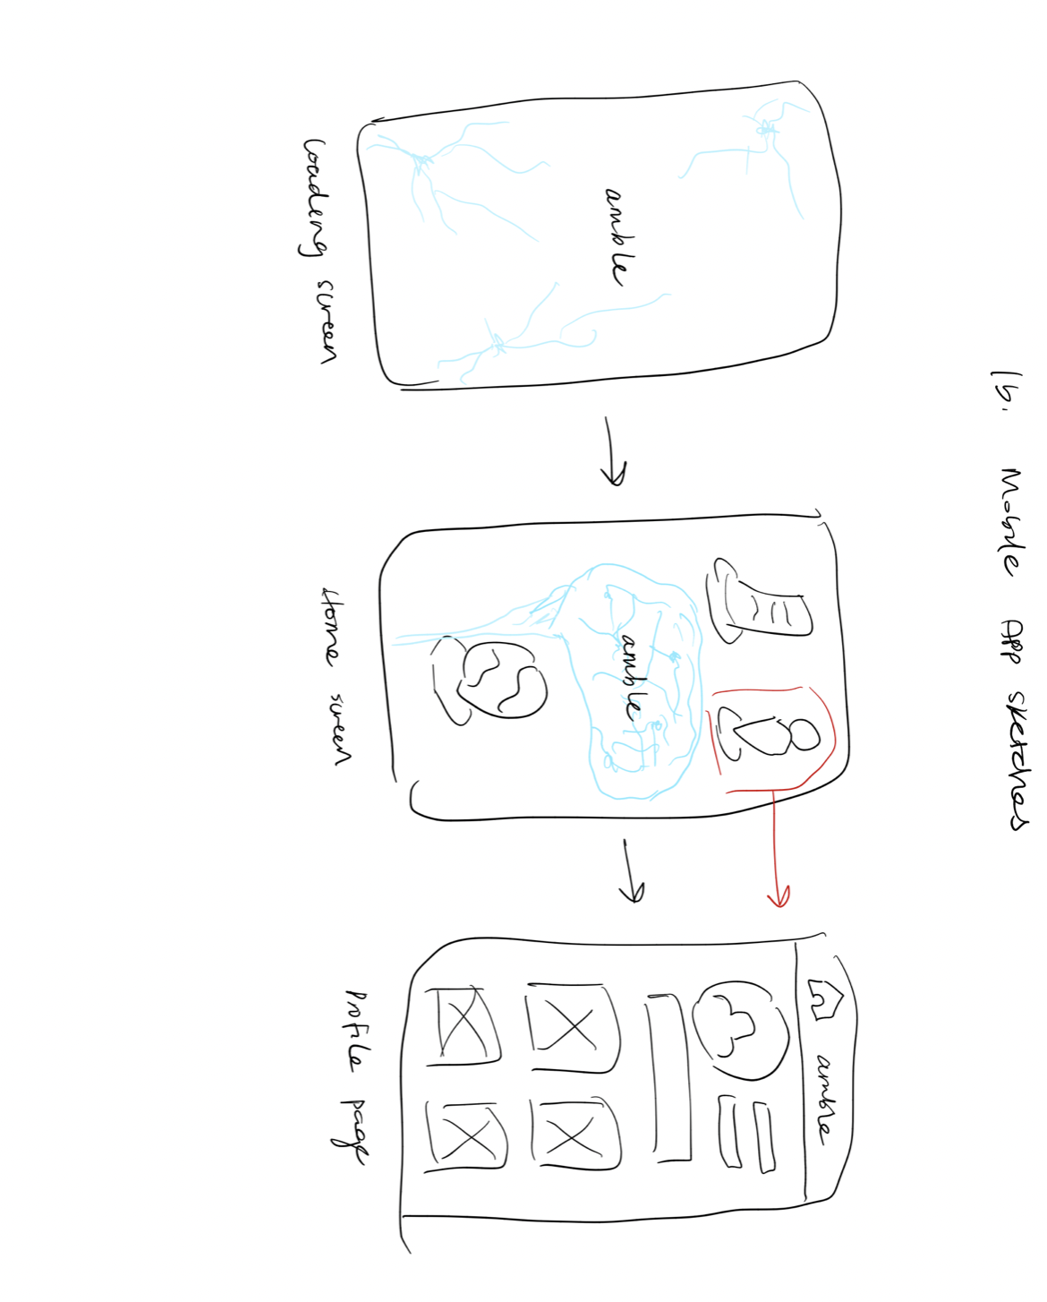
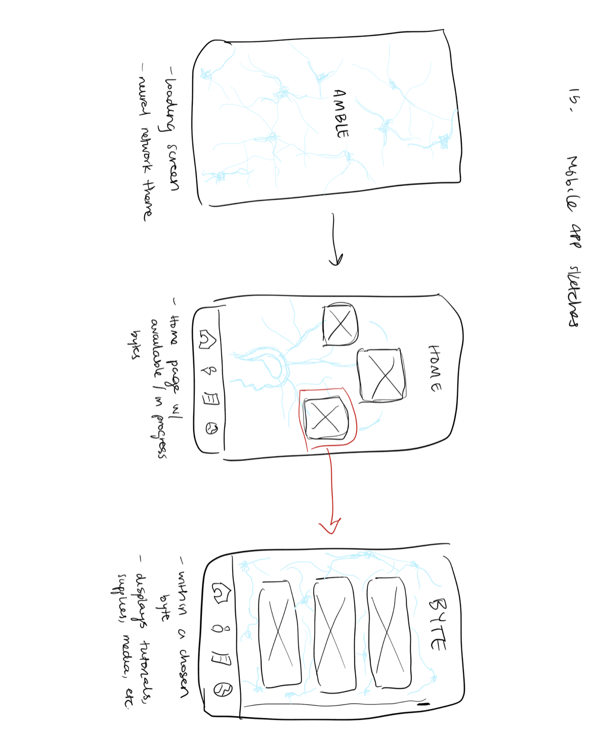
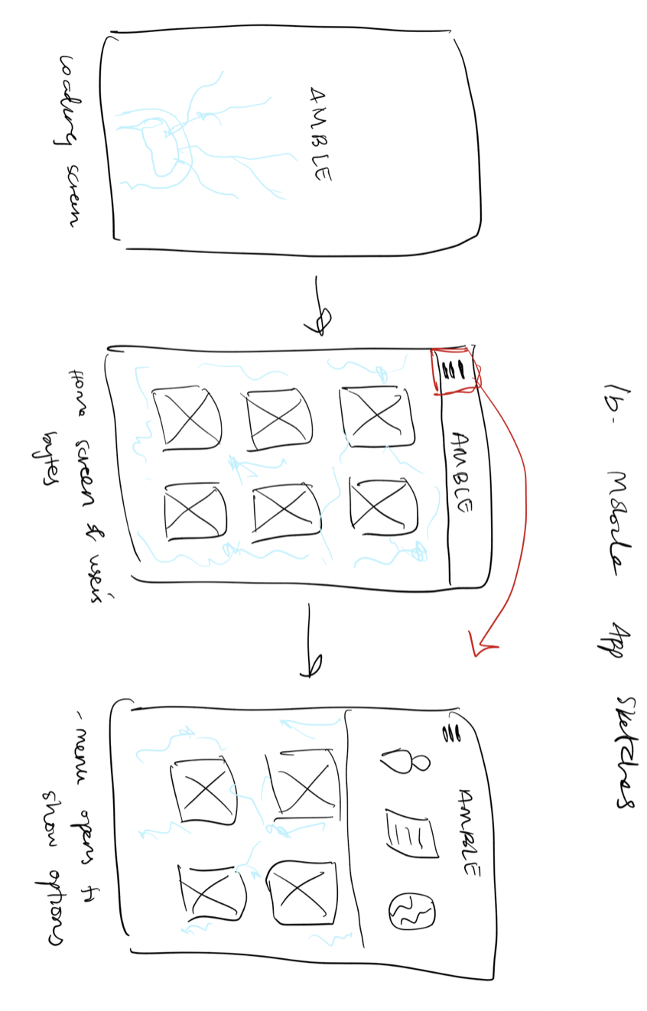

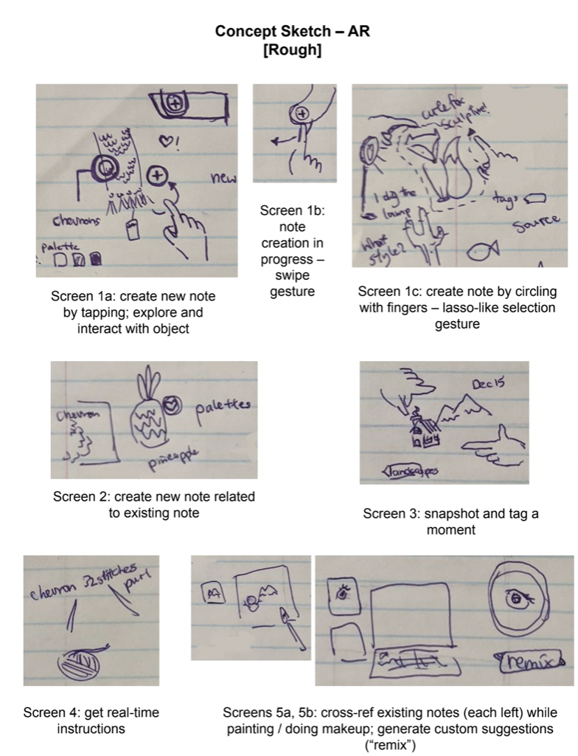

From Low-Fi to Med-Fi
Going from Low-Fi to Med-Fi prototype mainly involved incorporating aesthetic changes to our UI, as most of our feedback from testing was positive or beyond the scope of med-fi prototyping. Having the positive feedback helped immensely, and allowed us to trust our instincts when designing the aspects of the hi-fi prototype that we may not have explicit user feedback for.
Low-Fi Prototype
We used www.marvelapp.com to develop the low-fi prototype, as a way of quickly testing our three main UI task flows, where each screen was drawn out through paper sketches but you could emulate button features, scrolling, and other basic UI components.
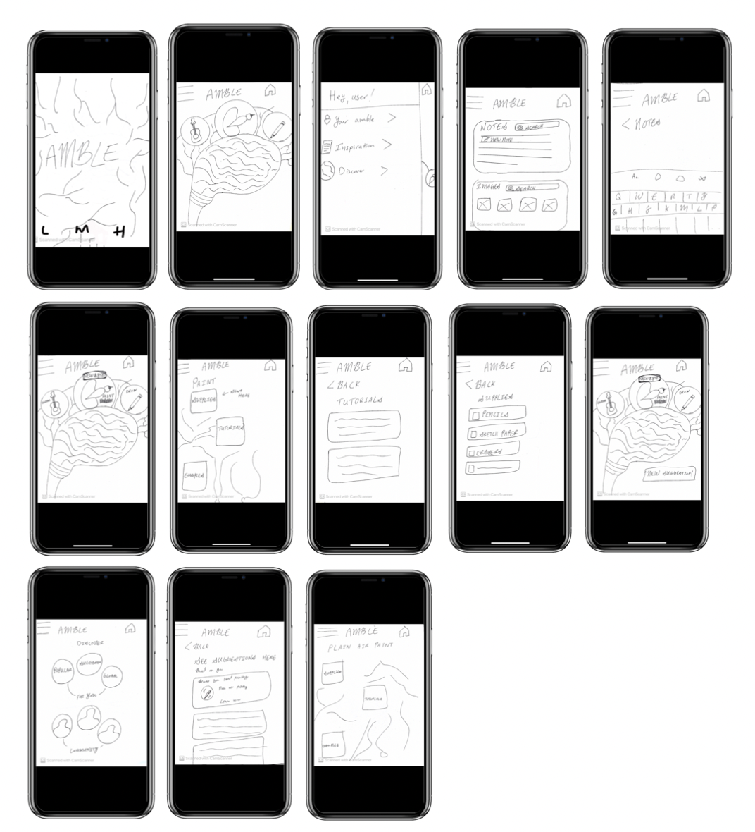

UI Task Flows
Task 1
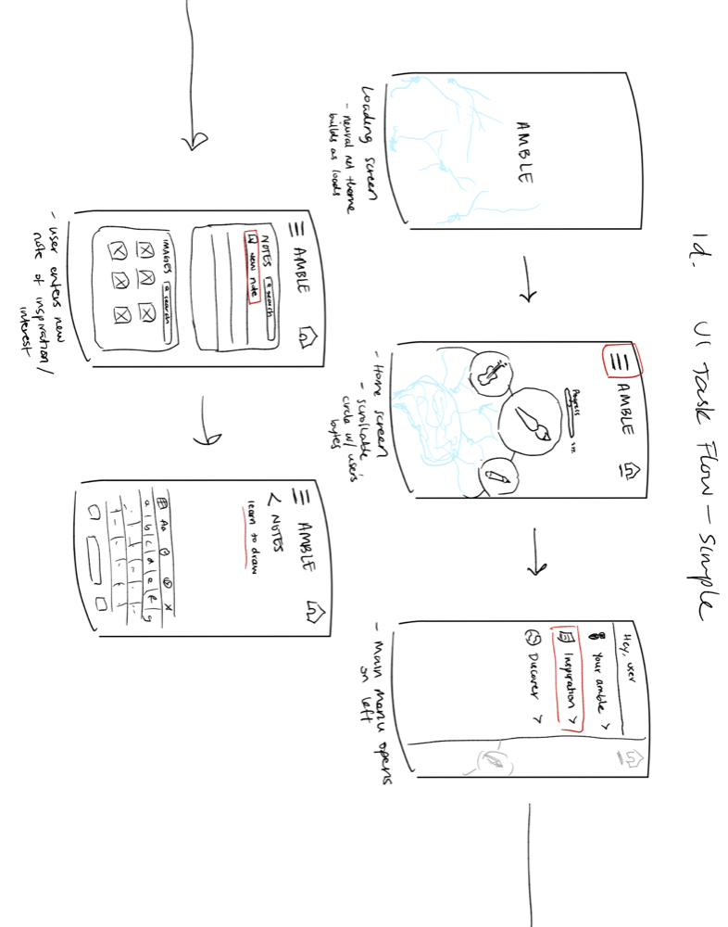
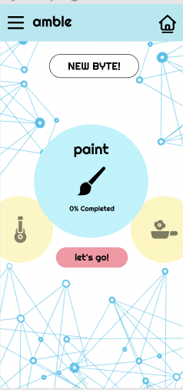
Simple Task Flow - Low Fi
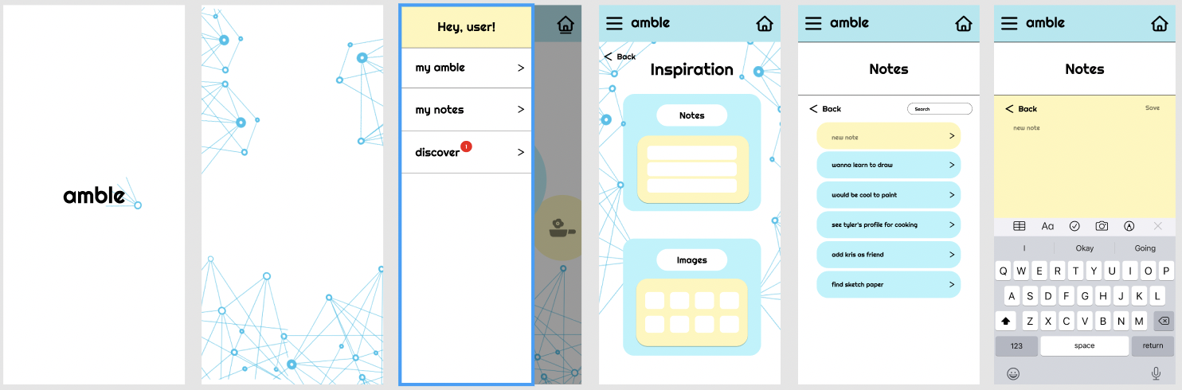
Simple Task Flow - Med Fi
The first task was to input and save ideas into one platform, which we found important to flesh out as a way of demonstrating how the user could use the application to start new creative projects while simultaneously keeping track of any notes they might have along the way. No significant changes were made from low-fi to med-fi for this task, as the only suggestions from user testing (ie. speech recognition) were beyond the implementation scope of the med-fi prototype.

Task 2
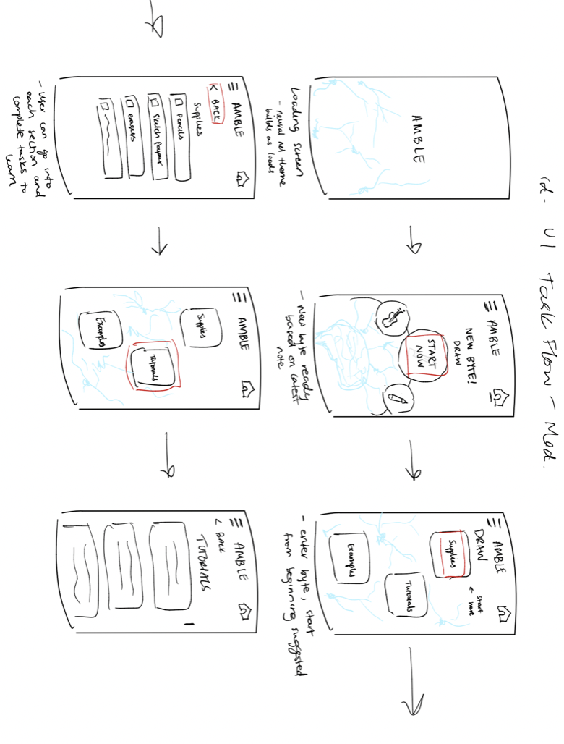

Moderate task flow - Low Fi

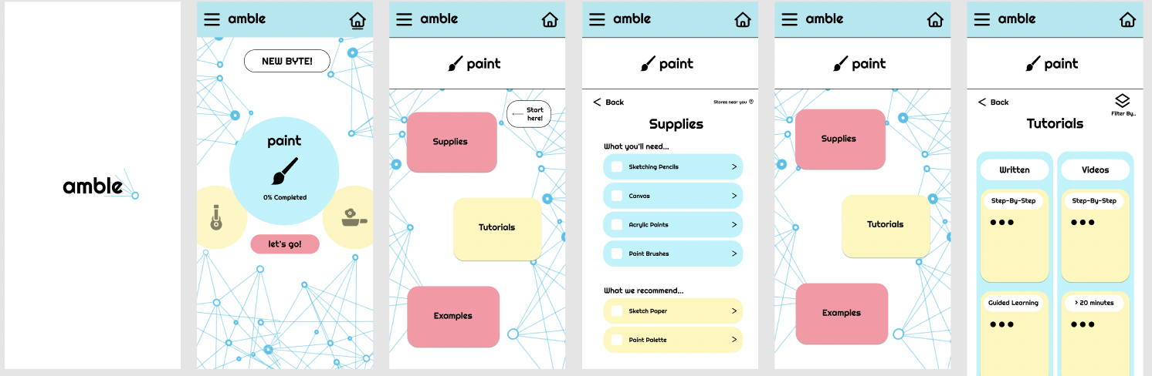

Moderate task flow - Med Fi

The second task is to explore interests in a friendly, easy to use manner. This task was imperative to our prototype testing, as a form of introducing activities, or ‘bytes’, to users in a way that was engaging yet comfortable for them. Our goal was to create a simple layout for each byte that could also allow for more complex and detailed interaction, sustained through clear navigation. The main changes to this task were on the tutorials screen, where we included different formats for tutorials.

Task 3
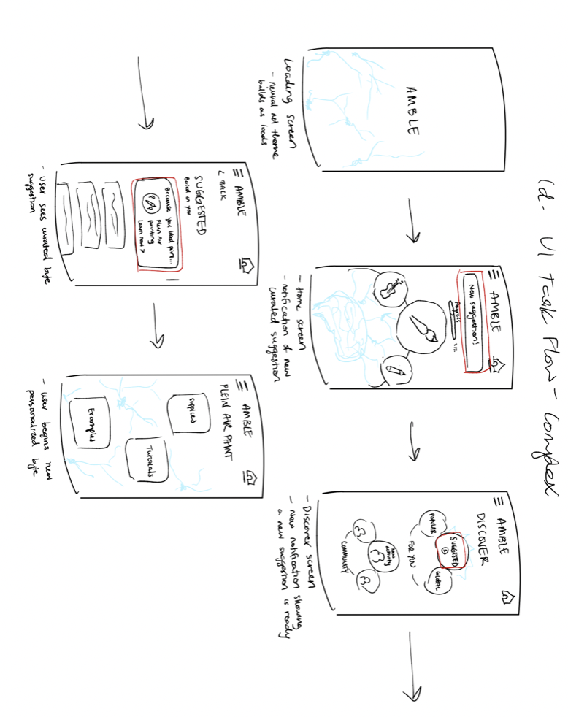

Complex task flow - Low Fi

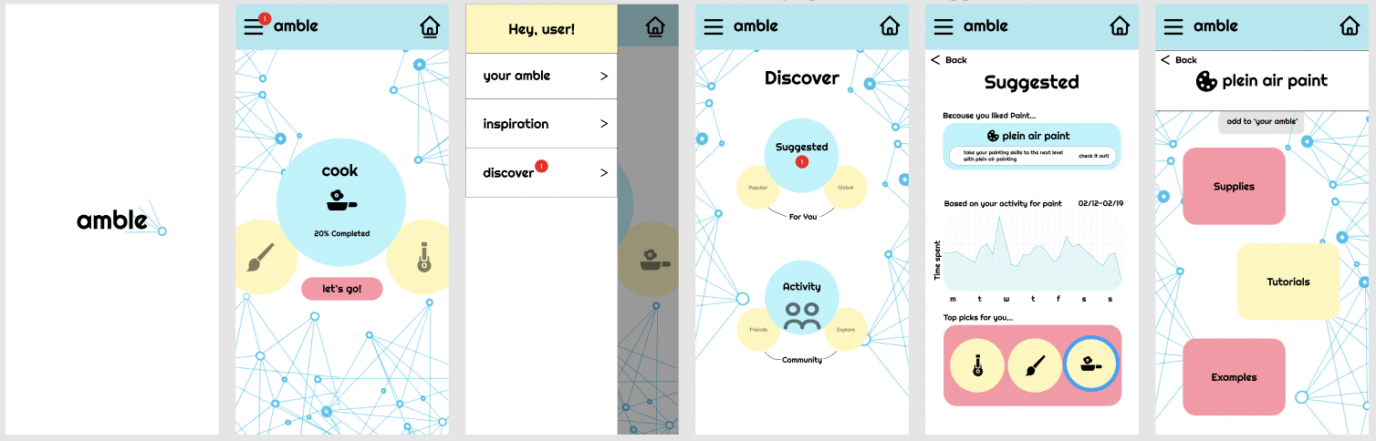

Complex task flow - Med Fi

The third task allows the user to build on previous hobbies by receiving suggestions from the platform on what to explore next, with a screen that shows them new activities to discover and relevant information about how their app usage on amble led to the new suggestion. Incorporating this task was crucial to demonstrating how amble would keep users engaged in the app, especially in the case where their current activities are not interesting to them. In cases like these, or cases where the user finishes their current ‘bytes’, they can explore in new directions or dive deeper into the same activities, through sustained interaction. Going from low-fi to med-fi mainly involved specifying what kind of data would be shown to the user and tracked by the application, which was not specified in the low-fi prototype. Based on user feedback that suggested we have less screens for certain tasks, we made the discover page accessible through the top left navigation ‘burger’.
From Med-Fi to Hi-Fi ~ Usability Problems Addressed
Developing our Hi-Fi prototype was mainly constrained by our limited coding abilities with React Native as a team. Our main form of user feedback was from the heuristic evaluations completed by class peers. While many of the errors described were beyond the scope of our prototyping and coding constraints, we were able to tackle some errors.
Task 1: Opening Note
H1: Visibility of system status / Severity 3 / Found by: D
There is no feedback given for creating a new note in inspiration. This may be
due to limitations of Figma and your med-fi prototype, given that you hard-coded
the note taking functionality, but if not be sure to provide the user with feedback
in the form of having the completed note show up on the screen and be added to
list of notes.
Fix: Provide user with feedback after creating a new note…(seen through the checkmark at the bottom after note is being typed).
H10 Help and documentation / Severity 3/ Found by A, B
The purpose of “inspiration” isn’t immediately obvious as a note taking section. Once you click on it it’s clear that it’s for notes but there’s no guidance on how notetaking should be used in conjunction with the rest of the app. How should I use this section?
Fix: A quick snippet suggesting what types of notes you should be taking.
H11 Accessible/ Severity 3/ Found by B, D
The interface for viewing “your amble” where you have to horizontally scroll through is not friendly to those who are using a screen reader, as only the current “amble” is labeled with text.
Fix: Label the options to the left and to the fit with text as well, or provide a list view.

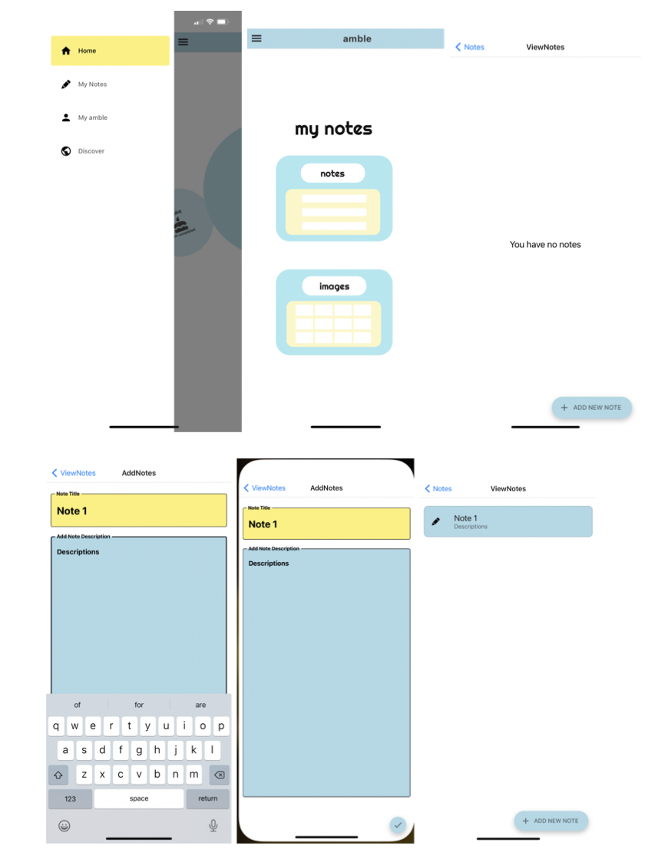

Task 2: Going to byte tutorial
- H6 Recognition rather than recall/ Severity 4/ Found by B
In the interface for viewing “Tutorials”, the screen is quite cluttered, and it is unclear what each of the yellow sections are supposed to represent. Furthermore, it’s unclear why there is “written” in one of the columns but not the other.
Fix: Consider splitting the “Tutorials” interface to multiple screens so it is easier for users to understand.

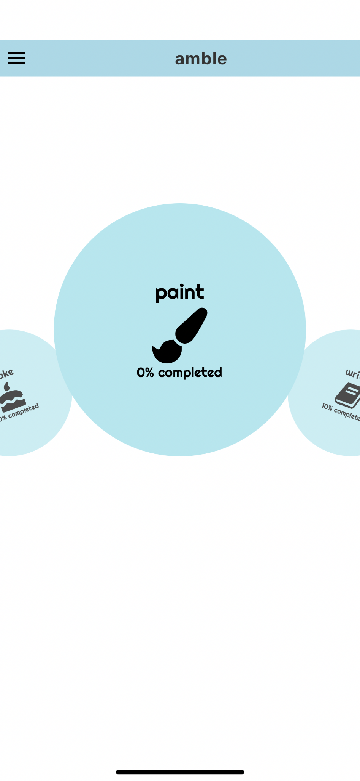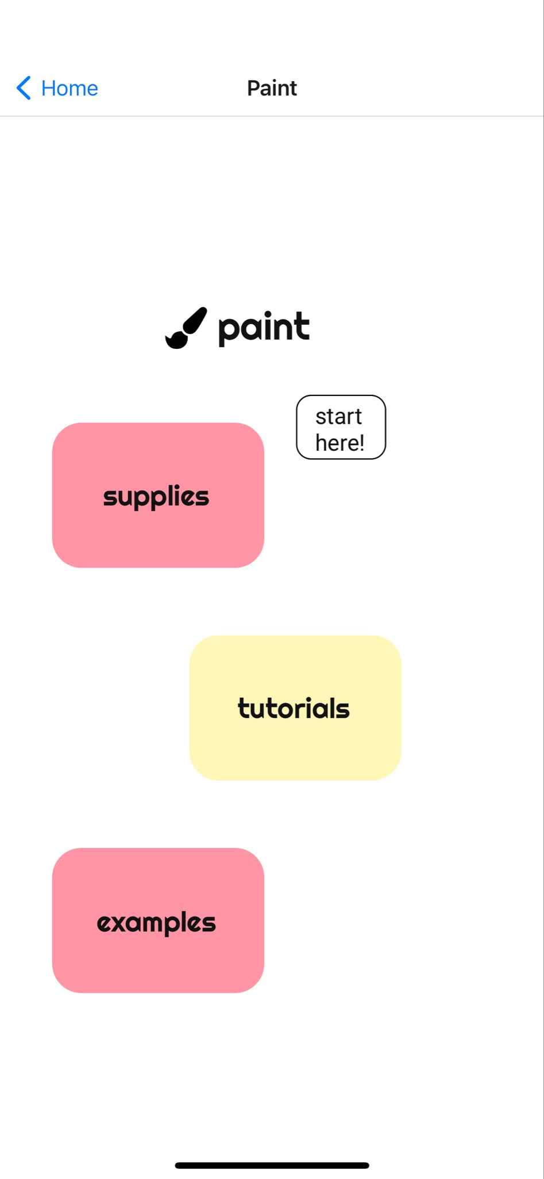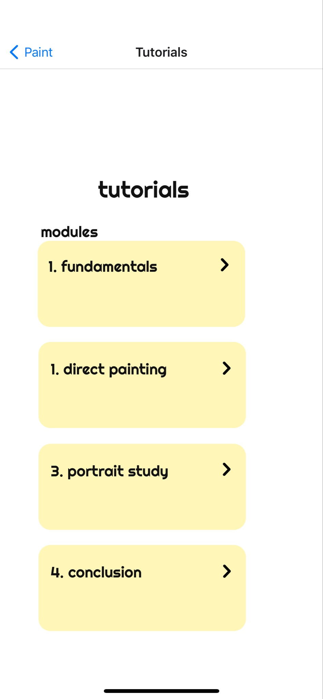

Task 3: Discover Page
H2 Match between system and real world/ Severity 4/ Found by B
In the interface for “Suggested”, the “Based on your history…” graph is difficult to understand: it’s unclear what it is showing and what the axes mean. It is also unclear why the users would want to see this in the first place.
Fix: Label the graph with a title and the axess. Reconsider if the graph is necessary.
H11 Accessible/ Severity 4/ Found by B
In the interface for “Suggested”, the “Top picks for you…” are not labeled with text, thus inaccessible to those using a screen reader.
Fix: Label the Top Picks with text.
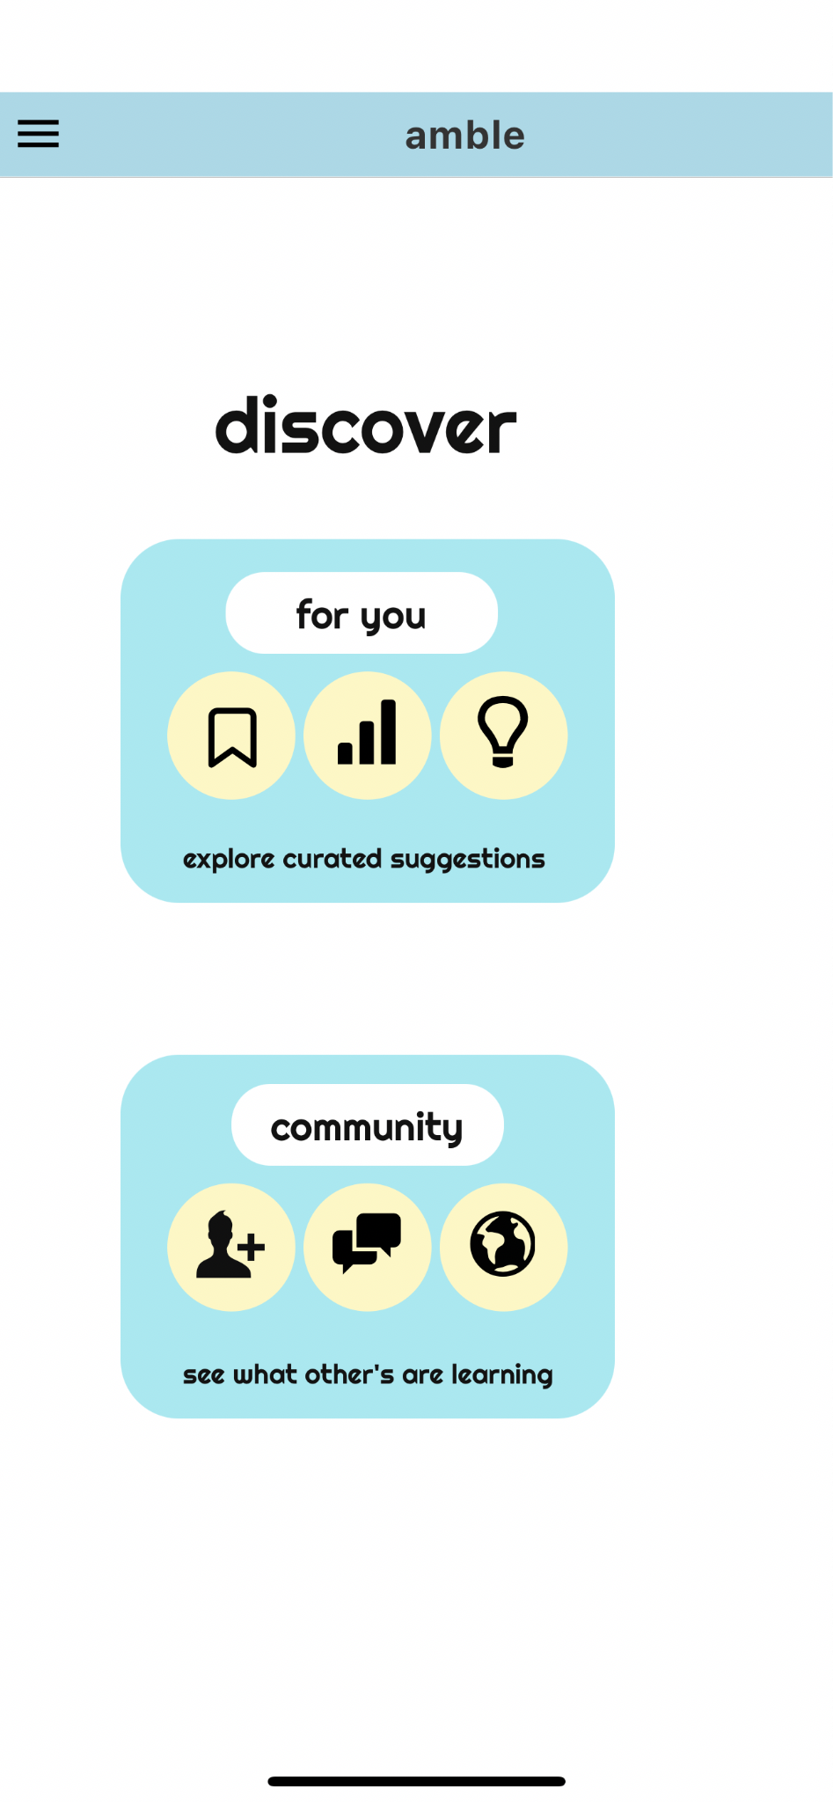
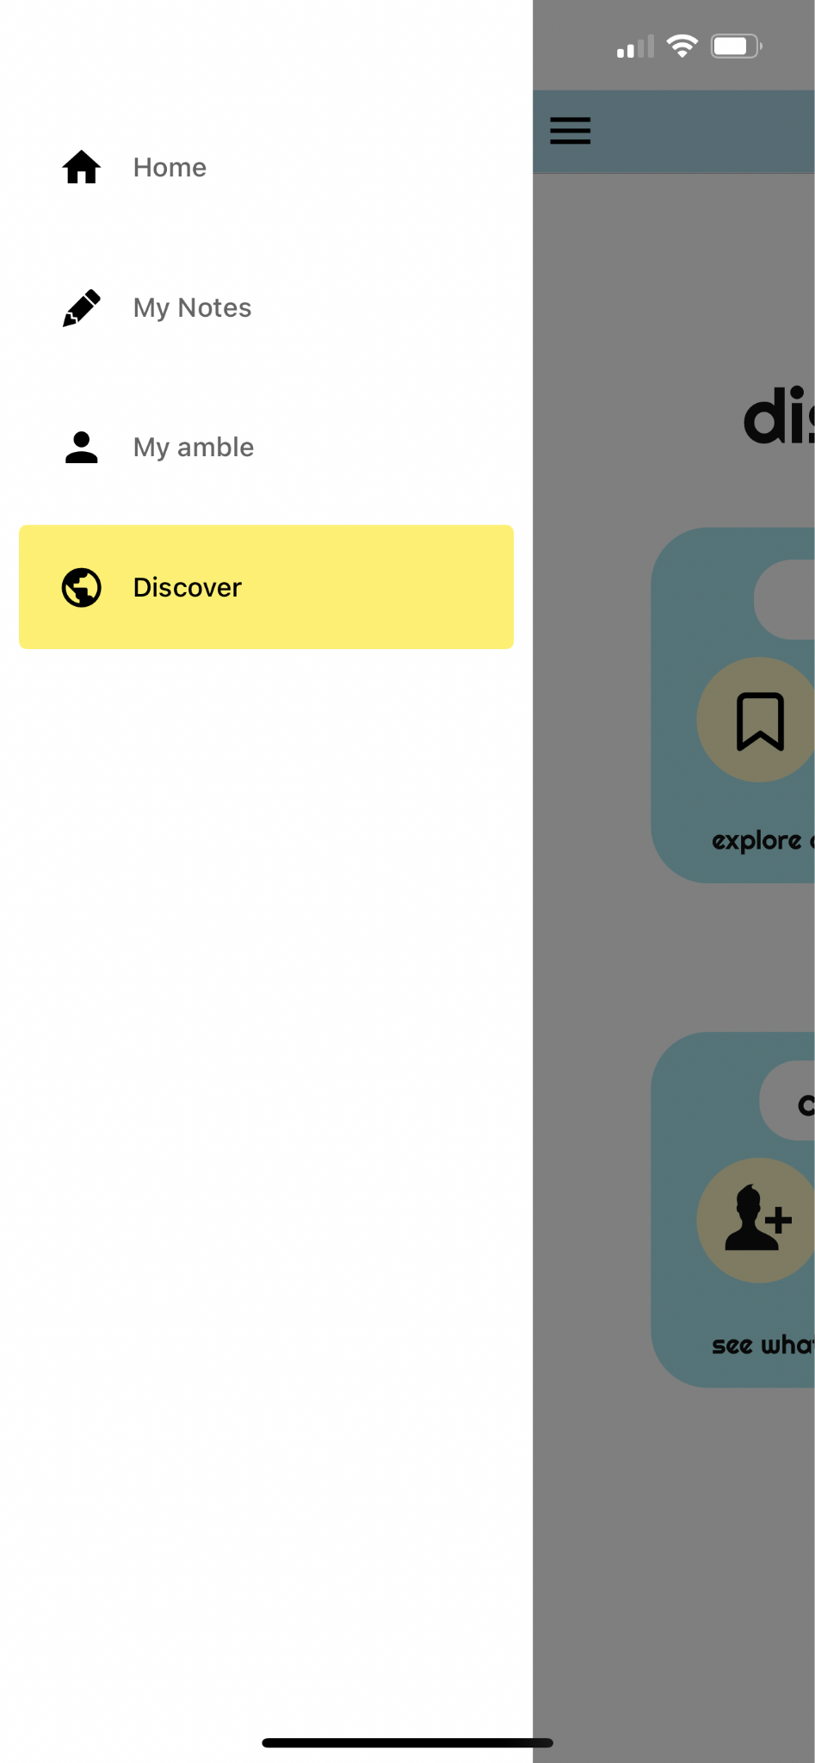
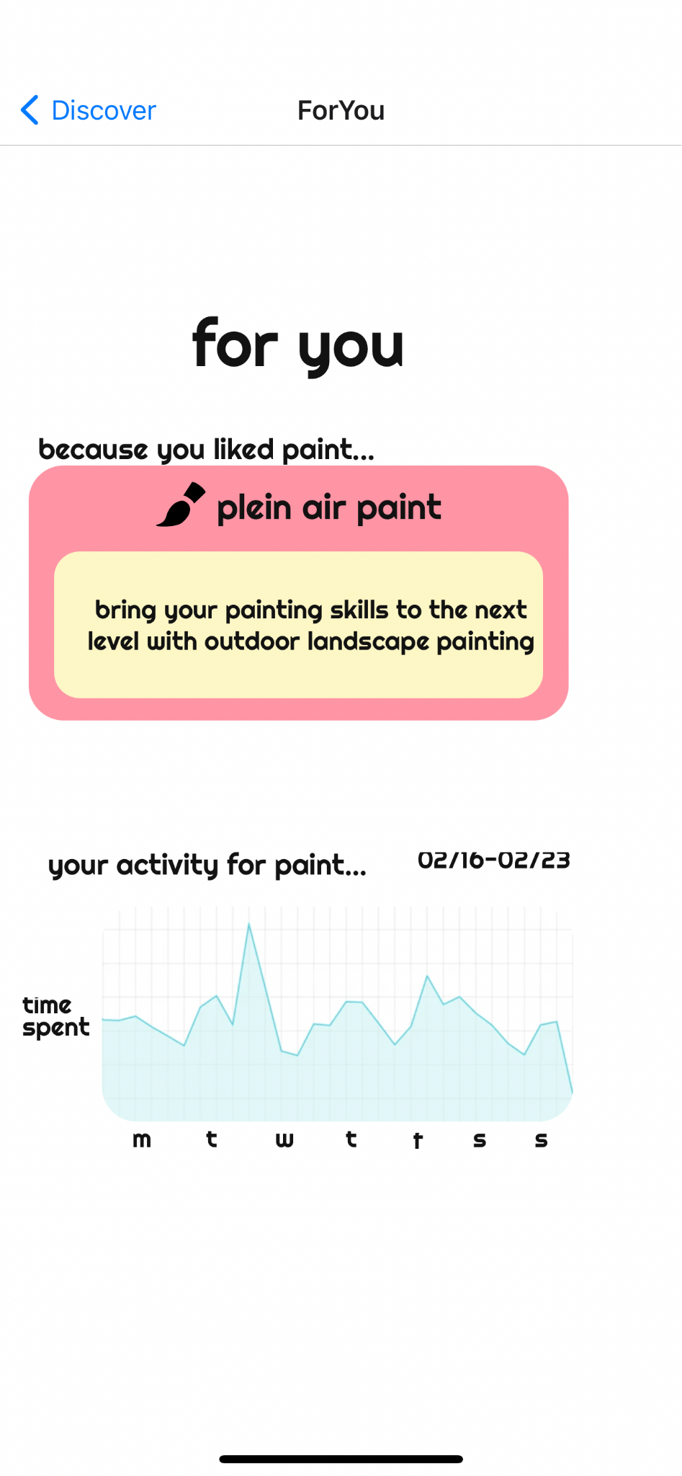

Values in Design
- We wish to make pursuing creative hobbies as painless and barrier-free as possible, making them more accessible and equitable.
- We wish to avoid choice paralysis and information overload, so we care about the efficiency with which information is organized.
- We wish to get more people engaged in creative activities, since it improves well-being and increases productivity.

We focused on implementing our first design value, of accessibility, by moving forward with a mobile application, as we found that phones would be the most accessible technology. Our second design value was reached by having all the main activities for each user on the main screen, separated by each activity. This way, it’s easy for users to click on a specific activity and have them organized on the carousel. Focusing on engagement, our last design value, was done through supplying the user with different activities in the ‘byte’, from supplies and tutorials to examples. Furthermore, we incorporated the discover page, with suggestions and a community page, as a way of keeping users engaged - either by learning about furthering their activities, or doing activities with others.

Prototype Implementation
Tools
We primarily used React Native to build the Hi-Fi prototype, as well as using BuilderX to create some components. React was a very helpful tool for creating this prototype, as it allowed for modulated coding that could be tested on multiple platforms, and specifically on mobile devices. In terms of the coding structure, the actual components that were used to create elements on the prototype were easy to understand, and then easy to reuse for other screens. BuilderX helped a lot with figuring out what the basic code structure would look like for specific components, based on designing them on their browser tool. However, there were strong limitations with actually using BuilderX for the overall layout, as the tool used a lot of dependencies and API’s. Thus, we ended up using BuilderX to aid in creating individual components.
We did not do many Wizard of Oz techniques, except for illustrating user data on the suggestions page. For this section, we added some images of graphic data as a form of showing what potential progress data may look like for users, and how it is used to craft suggestions on the app.
Future Work
Given the time constraints of the project and the limited coding abilities of the team, we were not fully able to flesh out the application beyond the three tasks we showed. With more time, we would like to add other features, such as:
- Fleshing out community feature
  - Sending texts, making groupchats based on activities
  - Seeing your friends’ activity progress
  - Starting or joining activities with others
- Adding ‘Settings’ to customize the application for greater accessibility
- Adding ‘Help’ sections to limit user confusion
- Sharing features to post your progress on other social media

Summary
Working on this project has been an incredibly fulfilling experience for the team. We learned how detailed the design process is, and the importance of every step, as each builds on the next. Every step, as early as our needfinding and early brainstorming, can still reflect in our hi-fi prototype. The design process flows like a stream, and it requires that everyone actively participate and engage with the project. While there were some tasks that were not as critically analytical, most of the significant turns in the project came from high-level brainstorming. Each part was also very iterative, especially when it came to prototyping. Designing the better product came with going back and forth, and revisiting earlier iterations, to get the best result.
For most of us, this was our first time working on a team to develop an application, and we learned a lot about using each team members’ skills and strengths to fairly and efficiently develop our project. Looking back at the initial thoughts we all had on our studio theme, it’s mind blowing to think how our thoughts became a fully fleshed out concept and prototype. Becoming Iron Man is all about expanding your senses, which includes your creative sense and even your skills. The hobbies you practice everyday strengthen your biological senses, which is how amble is involved.

